# SSO Workflow Diagram (PNG)

Here is the downloaded image of the SSO & Agent-to-Agent Workflow. You can right-click the image to save it to your computer.

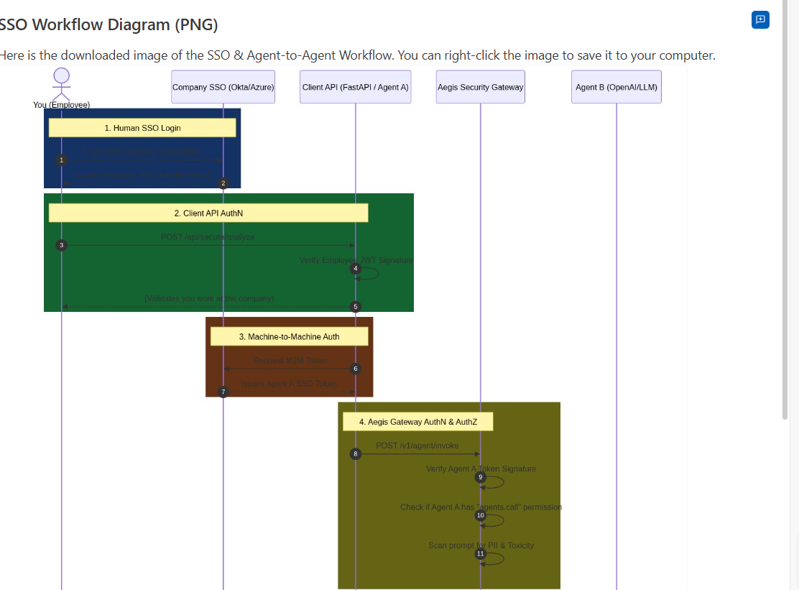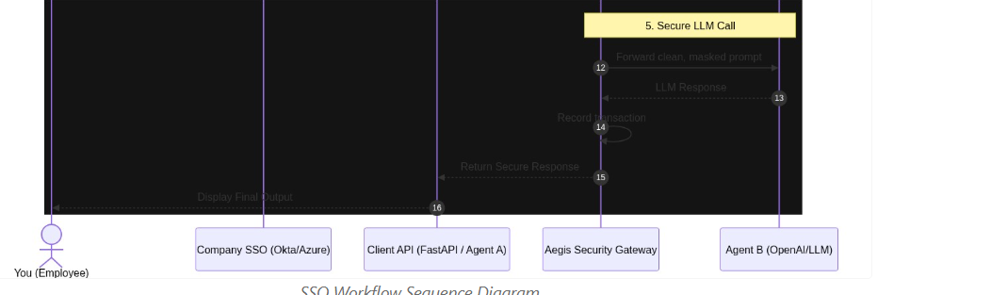
Viewed main.py:1-37

In FastAPI, you don't want to manually copy and paste `Depends(verify_end_user_auth)` into every single API endpoint. That is error-prone and hard to maintain!

Instead, to automatically apply Authentication and Authorization to **every API**, you should use **Global Dependencies** or **Routers**. Here is exactly how you do it:

### 1. The FastAPI Way (For your Client App)
You can group all of your secure endpoints into an `APIRouter` and apply the authentication dependency to the router itself. This guarantees that *every* endpoint attached to that router requires a valid token.

```python
from fastapi import APIRouter, Depends

# Create a router that requires Authentication globally
secure_router = APIRouter(
prefix="/api/secure",
dependencies=[Depends(verify_end_user_auth)] # Applied to EVERY endpoint below
)

@secure_router.post("/analyze")
async def secure_analyze():
# You don't need to check auth here anymore, the router did it for you!
pass

@secure_router.post("/process-data")
async def process_data():
# This is also automatically protected!
pass

# Attach the secure router to the main app
app.include_router(secure_router)
```

### 2. Handling Authorization (AuthZ)
If you want different APIs to require different permissions (e.g., one API requires `admin`, another requires `viewer`), you create a dependency factory that checks the specific permission.

```python
def require_permission(required_role: str):
def role_checker(token: str = Depends(verify_end_user_auth)):
# Decode the token and check the user's roles
# If they don't have `required_role`, raise HTTP 403 Forbidden
pass
return role_checker

# Now you can easily authorize specific APIs:
@app.delete("/api/admin/delete", dependencies=[Depends(require_permission("admin"))])
async def delete_data():
pass
```

### 3. How the Aegis SDK does it
If you look inside the `AuthenticationSDKAI` you'll notice the Aegis Server takes a similar approach, but uses the `SecurityPipeline` object. For every single API call to Aegis, it runs:

```python
result = await _pipeline.secure_agent_call(
token=authorization,
required_permission="agents.call", # Aegis handles the AuthZ check for you!
...
)
```
This forces the request through a massive 9-step pipeline (AuthN, AuthZ, PII Masking, Rate Limiting, Toxicity Checks) all in one single function call, meaning developers can't accidentally forget a security step.

Would you like me to rewrite your `main.py` client application to use the `APIRouter` method so you can see the best practice in action?

